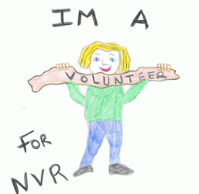

Active NVR Parent Volunteers Required
If you….

- have completed an NVR parenting course

- have gained a good understanding of the NVR approach and skills

- are ready and willing to share some of your NVR lived experiences with other parents

- can spare 6 hours of your time over 12 weeks with a view of becoming involved in a future parent group

- would be willing to participate in one-to-one mentoring with an NVR parent mentor

You are the right person for us.

Please contact Elisabeth Heismann by Monday, the 7th November 2016
Mobile No: 07557745985 e-mail: heismanne@gmail.com
NVR Action & Practice CIC

